A
Study
On
Project Title
The report submitted
for the partial fulfilment of the requirements for the completion of Skill Test - Mini Project for
B.B.A. I Yr. Semester I

Submitted By,
RAJPUT SAI HARSHITHA SINGH
201225684035

Under the Guidance of
Mrs. Priyamvada
Assistant Professor

Department of Computer Science
SIVA SIVANI DEGREE COLLEGE
(Autonomous)
Kompally (v), Secunderabad-500014

DECLARATION

I Sai Harshitha Singh, a student of BBA (I CH) I Semester of SIVA SIVANI DEGREE COLLEGE, hereby declare that, the Mini project titled “Inventory Management Dashboard" is an original work done by me under the guidance and supervision of Mrs. Priyamvada, Assistant Professor, Department of Computer Science, SIVA SIVANI DEGREE COLLEGE, SECUNDERABAD.
Further, I state that this project work is the result of my own efforts and have not plagiarized or submitted the same work for the award of any other certificate.
In case this undertaking is found incorrect, I accept that my project work will be rejected.

Rajput Sai Harshitha Singh
201225684035

ACKNOWLEDGEMENT

The success of this Mini project is credited to people who have helped me and I find that it is my duty to convey acknowledgement and sincere thanks to them.
I take much pleasure to express my deep sense of gratitude and thankfulness to my Mini Project guide Mrs. Priyamvada, Assistant Professor of SIVA SIVANI DEGREE COLLEGE for the valuable guidance and constant co-operation throughout my Mini project work, which helped me to gain more knowledge and develop my practical thinking.
I am thankful to the Principal Mrs. P. MAMATHA, for her co-operation throughout the completion of my Mini project and for providing the necessary lab equipment.
I also express my deepest gratitude to my parents.

Rajput Sai Harshitha Singh
201225684035

TABLE OF CONTENTS:
SL.NO | TOPIC | PAGE NO.
1 | Introduction / Executive Summary
2 | Objective
3 | Methodology
4 | Tools Used
5 | System Design
6 | Data Pre-processing
7 | Visualizations
8 | Results & Insights
9 | Conclusion
10 | References
11 | Appendix

INVENTORY MANAGEMENT DASHBOARD USING POWER BI:

The Inventory Management is the process of storing,tracking and analyzing of the data by controlling the goods in an organization. Proper way of inventory management helps the businesses to avoid product shortages and excess stock. This Power BI project mainly focuses on creating an Inventory Management Dashboard using Power BI , which in return helps to analyze the stock levels and inventory movement. This project’s dashboard provides us a clear sort of visual way of information which helps in better planning and decision making. The Power BI tools help us to make inventory data easy to understand and manage effectively.

By using and presenting the inventory data through charts, tables and indicators, the dashboard helps the managers to quickly analyze and understand the inventory performance. In advance, this dashboard ultimately helps to reduce inventory costs, avoid stock shortages and improve the overall efficiency of the company.

Power BI is a powerful business intelligence tool from Microsoft that transforms raw data into interactive dashboards and insightful reports with just a few clicks. In this mini project, we build a simple yet complete Sales Performance Dashboard using the free Power BI Desktop. Starting from importing clean sample data (Microsoft’s Financial Sample Excel file), we clean and shape it in Power Query, create essential relationships, write beginner-friendly DAX measures for key metrics like Total Revenue, Profit, and Profit Margin, and then design an attractive one-page dashboard with visuals, slicers, and basic interactivity. The goal is to experience the full end-to-end workflow — Get Data → Transform → Model → Calculate → Visualize in under a couple of hours, making it the perfect first hands-on project for anyone new to Power BI.
POWER BI DESKTOP:
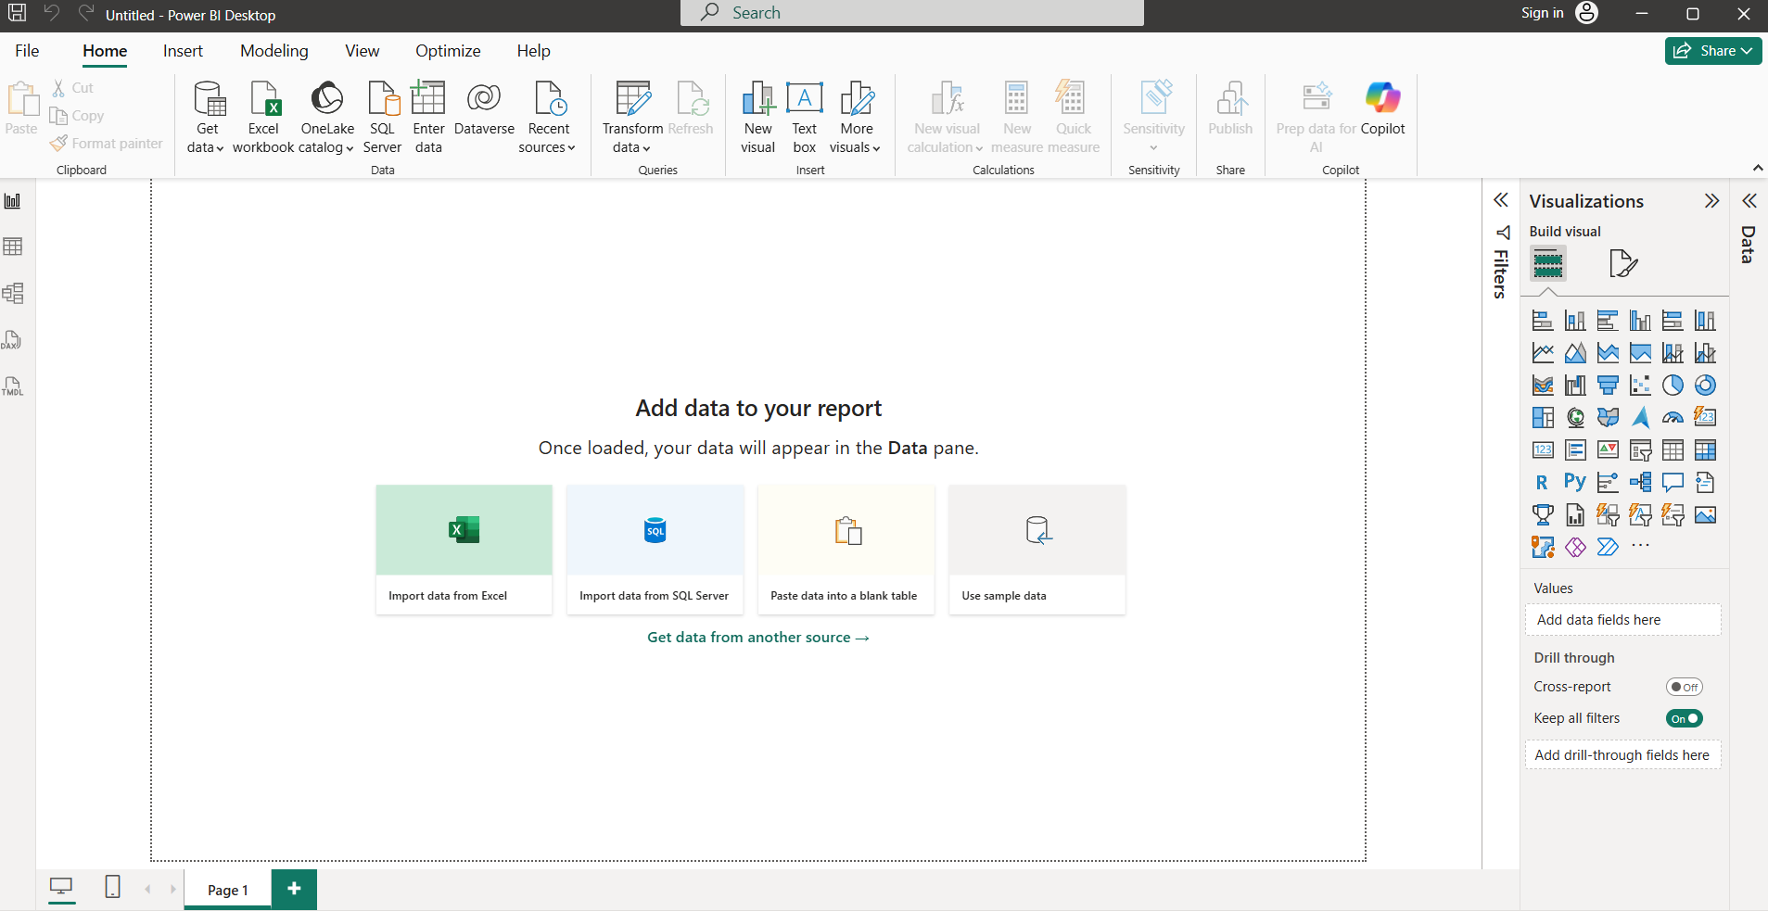

By the end of this mini project, you’ll have a functional, good-looking dashboard you can publish to the Power BI Service, share via link, or add to your resume/portfolio. More importantly, you’ll understand core concepts that apply to almost every real-world Power BI project: why relationships matter, how DAX turns numbers into business insights, and how small formatting choices (colors, titles, conditional formatting) dramatically improve readability and impact. This foundation lets you confidently move on to slightly more advanced mini projects such as inventory tracking, HR analytics, or personal expense dashboards all while keeping things practical, visual, and achievable even if you’re starting from zero.
OBJECTIVES:
• To understand inventory data clearly.
• To check available stock levels.
• To identify products with low stock.
• To track stock coming in and going out.
• To avoid shortage of products.
• To reduce excess inventory.
• To improve inventory planning.
• To support better business decisions.
DATA DESCRIPTION:
- Data Source:
- The data which is used for this project is collected from MS Excel.
- The Excel is helpful to store the inventory details such as products, stock levels and suppliers.
- This Excel file is imported into Power BI for analysis and dashboard creation.
2. Number of Records & Fields:
1. Number of Records (Rows): 10
2. Number of Fields (Columns): 10
3. Column Names:
• Product ID
• Product Name
• Category
• Supplier
• Opening Stock
• Stock In
• Stock Out
• Closing Stock
• Reorder Level
• Inventory Value
4. Key Columns and Their Meaning:
• Product ID: Unique identifier for each product
• Product Name: Name of the inventory item
• Category: Classification of products
• Supplier: Vendor providing the product
• Opening Stock: Stock available at the beginning
• Stock In: Quantity added to inventory
• Stock Out: Quantity issued or sold
• Closing Stock: Remaining stock after transactions
• Reorder Level: Minimum stock required before reordering
• Inventory Value: Total monetary value of stock
5.Data Type:
- Type of Data: Structured Data
Datatypes of Columns:
- Numerical: Opening Stock, Stock In, Stock Out, Closing Stock, Reorder Level, Inventory Value
- Categorical: Product Name, Category, Supplier
- Identifier: Product ID
NUMBER OF TABLES:
2 Tables
TABLE 1: INVENTORY
Fields:
- Product Name
- Category
- Supplier
Sample Data Used:
TABLE 2: SUPPLIERS
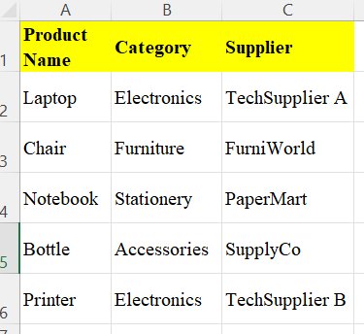
Fields:
- Supplier Name
- City
Sample Data Used:
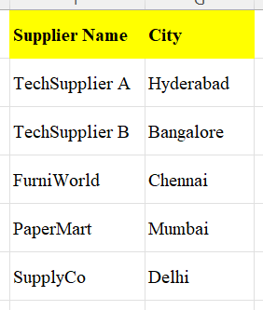
DATA MODELING:
After creating two tables, Model View was used to create relationship between them.
Supplier Name (Suppliers Table).
connected to Supplier (Inventory Table).
- Many to one(*:1)
EXPLANATION:
- Many suppliers can buy same type of products.
Example:
TechSupplier A → Laptop, Printer
- Cross Filter Direction: Single
- This ensures proper data flow between tables.
STEP-BY-STEP PROCEDURE:
- Open Power BI Desktop
- Click Home → Enter Data
- Create Inventory Table
- Click Load
- Repeat to create Suppliers Table
- Go to Model View
- Drag Supplier Name to Supplier column
- Select One-to-Many cardinality
- Click OK
- Go to Report View
DASHBOARD VISUALS CREATED:
1.Table Visual:
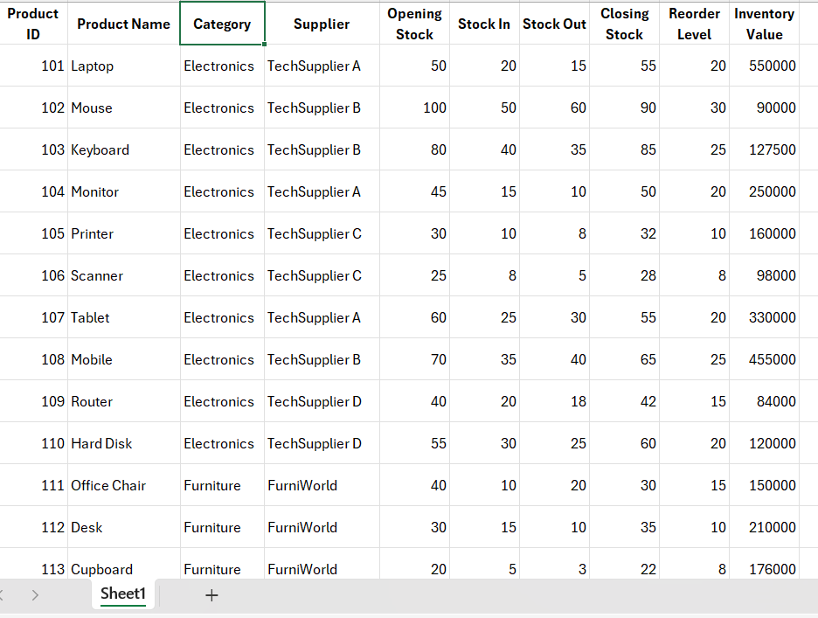

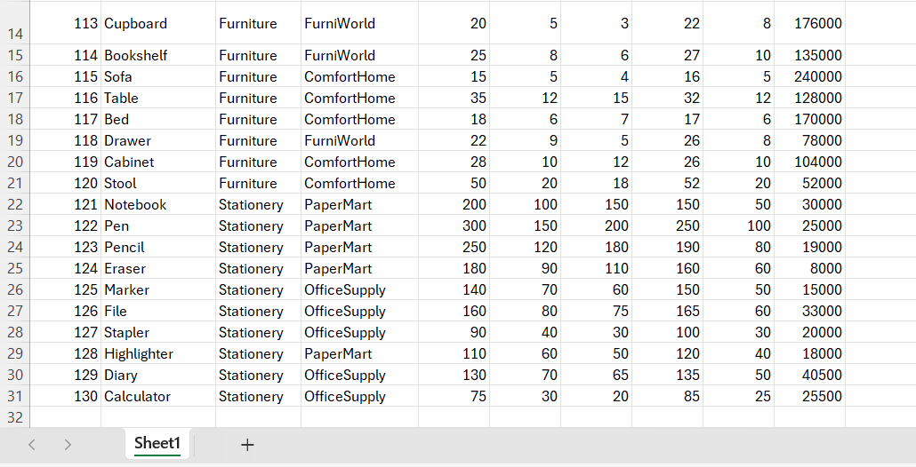

Purpose:
Displays complete inventory information
INVENTORY MANAGEMENT SYSTEM ANALYSIS USING POWER BI:
1. Step-by-Step Procedure (Data Import)
a. Open Power BI Desktop
Open Power BI Desktop from your system.
b. Click on Home → Get Data
c. Select Excel (or CSV if your file is CSV)
d. Choose your Inventory Data file
e. In the Navigator window, select the sheet that contains columns like:
• Product ID: Unique identifier for each product
• Product Name: Name of the inventory item
• Category: Classification of products
• Supplier: Vendor providing the product
• Opening Stock: Stock available at the beginning
• Stock In: Quantity added to inventory
• Stock Out: Quantity issued or sold
• Closing Stock: Remaining stock after transactions
• Reorder Level: Minimum stock required before reordering
• Inventory Value: Total monetary value of stock
1.Transform Data and Data Cleaning:
a. Click Transform Data
b. Click Use First Row as Headers
c. Remove Blank Rows
Home → Remove Rows → Remove Blank Rows
d. Check Stock Quantity and Unit Cost columns
Remove null or error values if any
e. Click Close & Apply
Data is now cleaned.
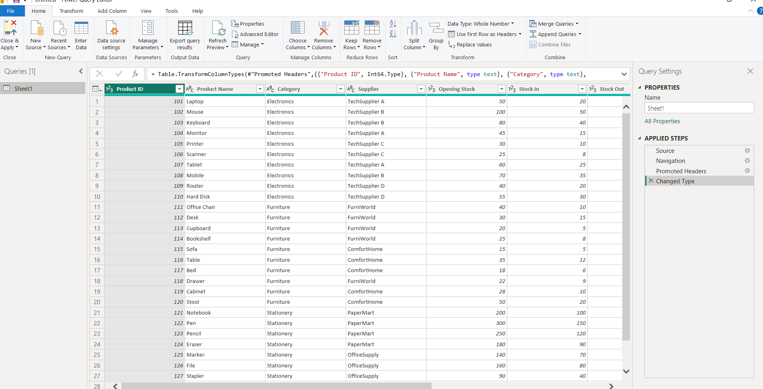
After clicking on use first row as headers.
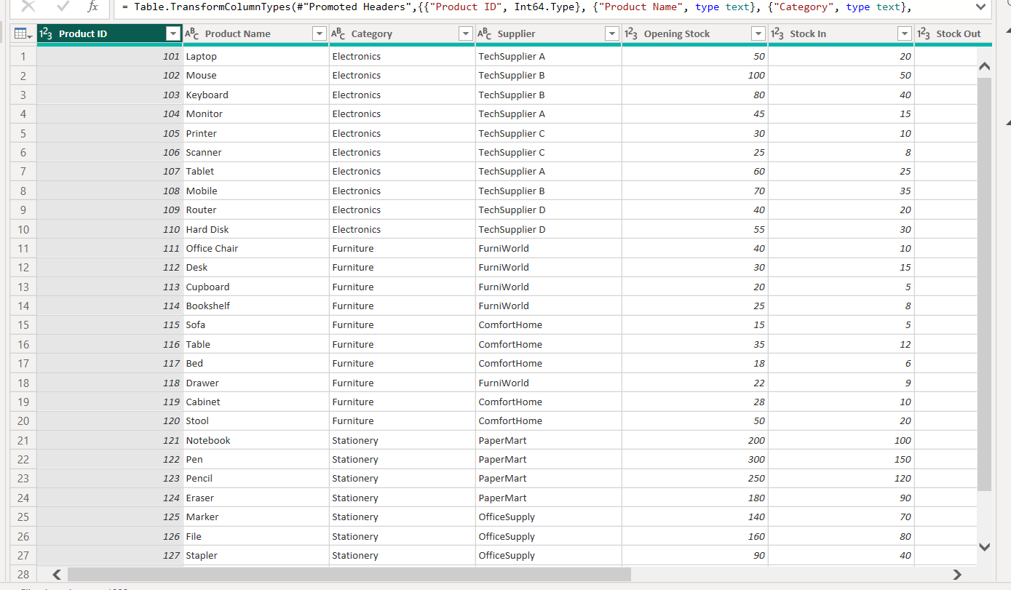
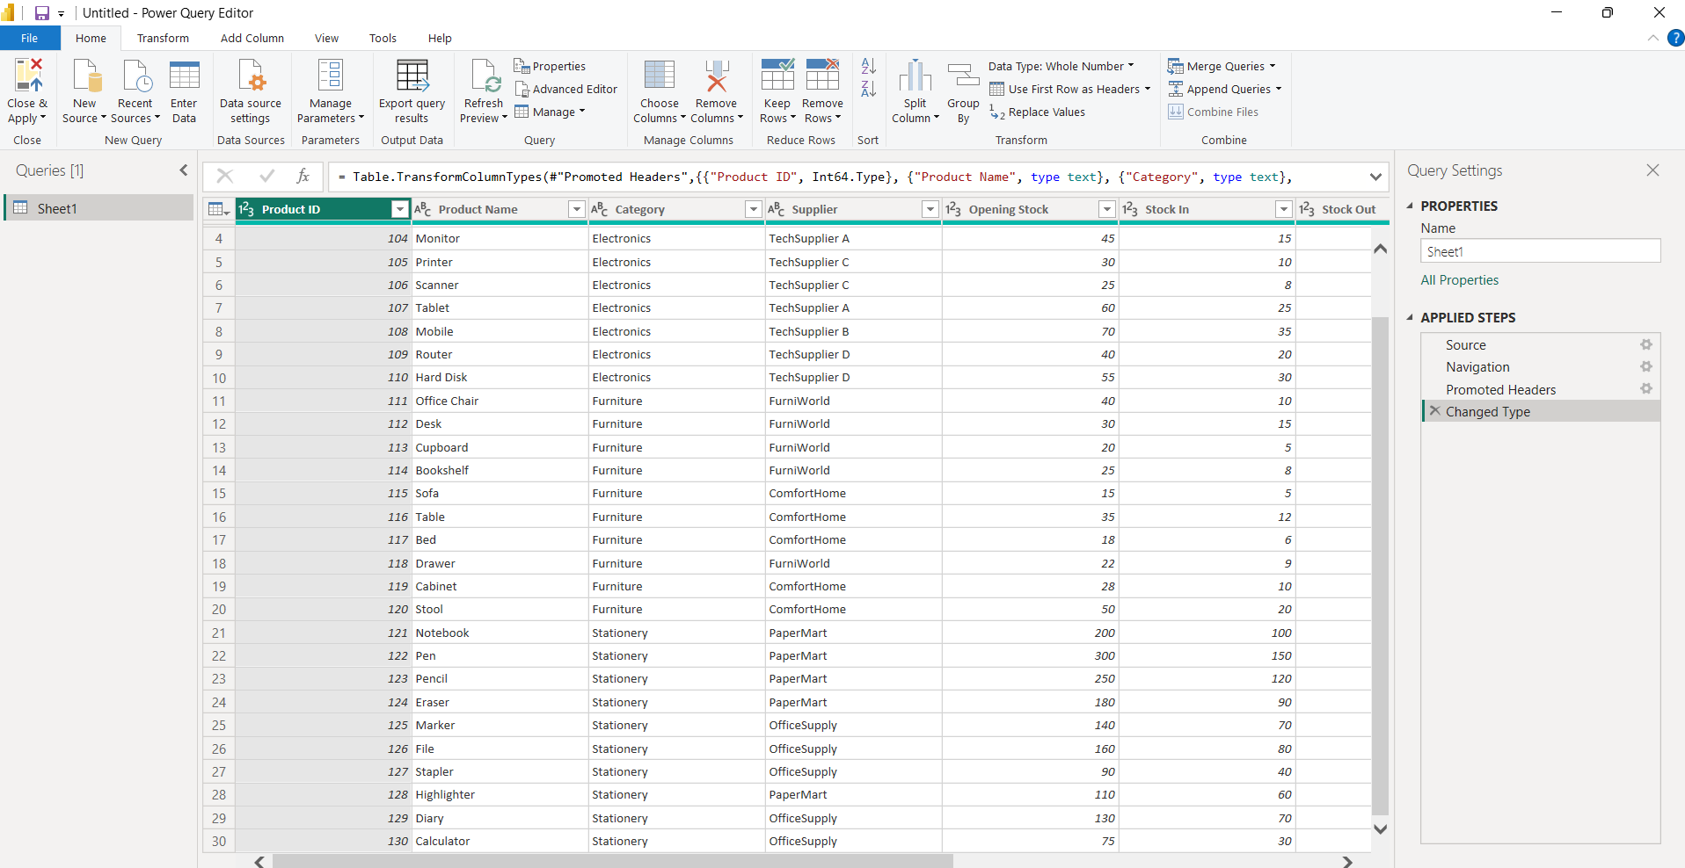

- Card chart:
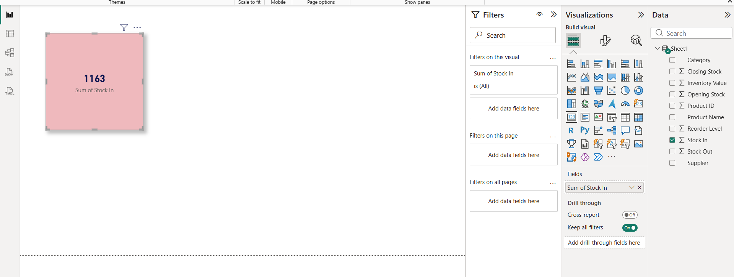
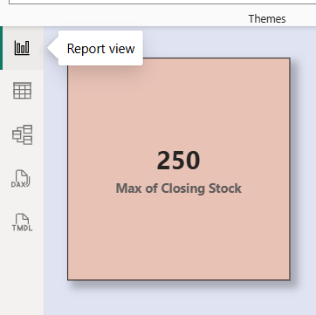
- Click on Model View (icon on left side)
- Arrange:
  - Suppliers table on left
  - Inventory table on right
- Ensure relationship line is visible between them.
This shows data flow between tables.
Findings: In the above card charts, we found how to visualize the max of closing stock value and sum of stock in through the help of card charts.
3.Stacked bar chart:
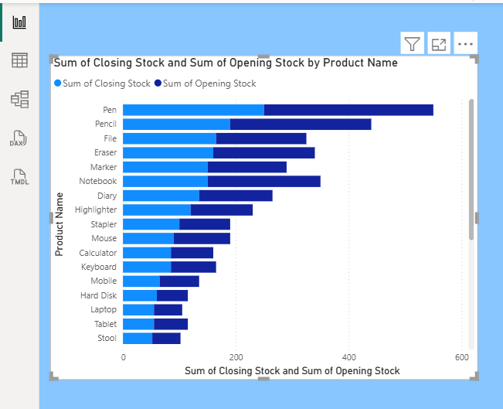
1.Go to Report View.
2.Click Stacked Bar Chart icon.
X-Axis: Sum of Closing Stock
Y-Axis: Product Name
Findings: Helped in identifying the sum of closing stock in respect to the Product Name.
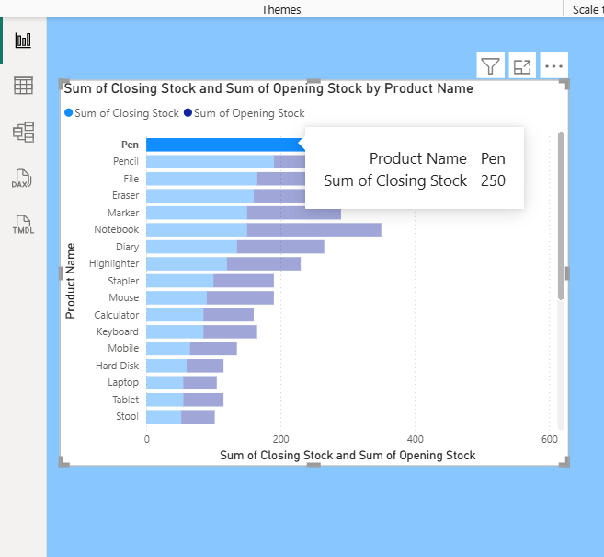
- Stacked column chart:
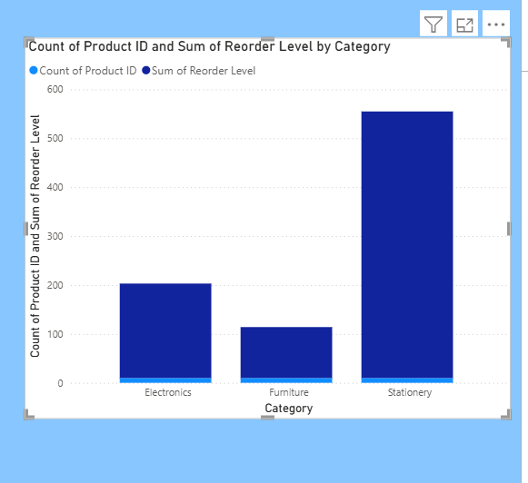
- Go to Report View.
- Click Stacked Column Chart icon from Visualizations pane.
- Drag Category→ Axis.
- Drag count of product and sum of reorder level→ Values.
- Click drop-down on StockQuantity (Values field) → choose Sum.
- Drag Warehouse → Legend.
Findings: Helps compare total stock across categories. Shows warehouse contribution for each category. Easy to identify which warehouse stores more stock.

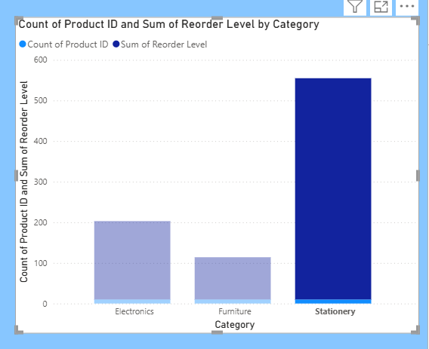
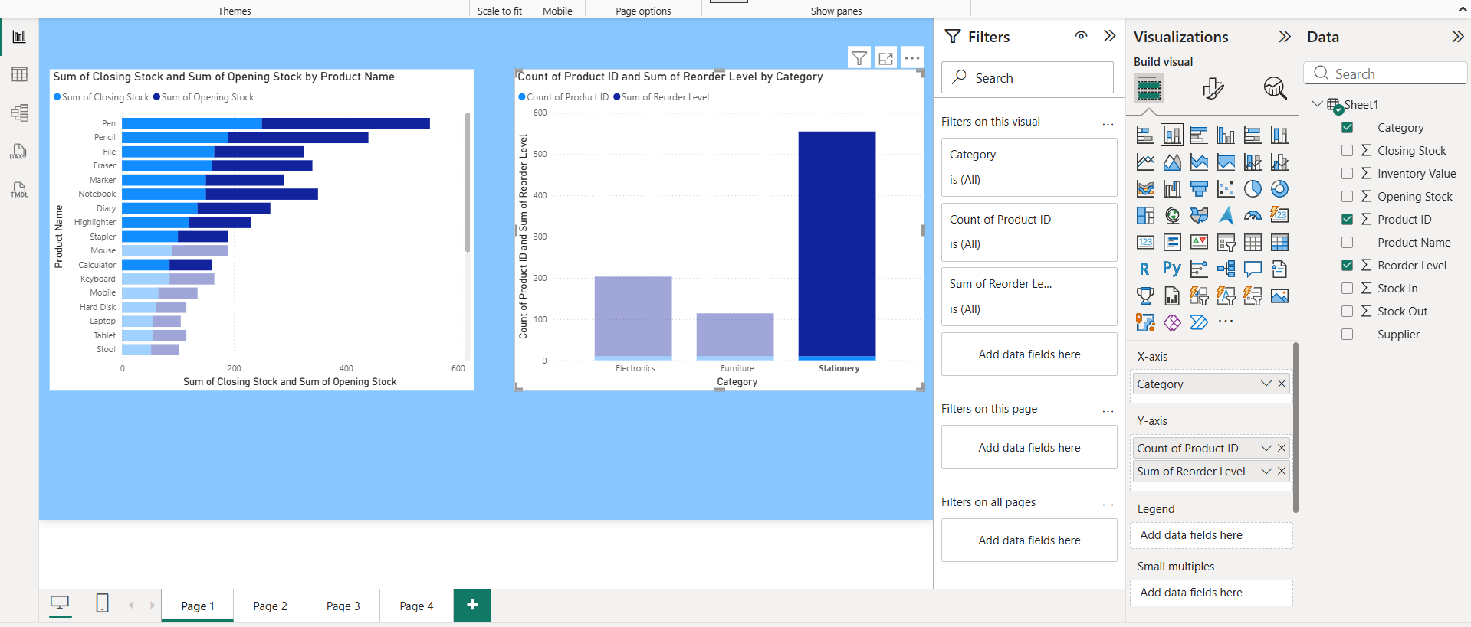
- Clustered column chart:
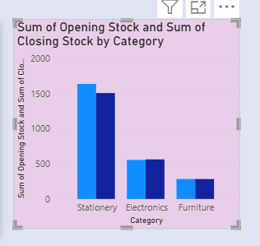
1.Go to Report View.
2.Click Clustered Column Chart icon from Visualizations pane.
3.Drag Warehouse → Axis.
4.Drag Stock Quantity → Values.
5.Click drop-down on Stock Quantity (Values field) → choose Sum.
6.(Optional) Drag Category → Legend if you want category comparison.
6. Area chart:
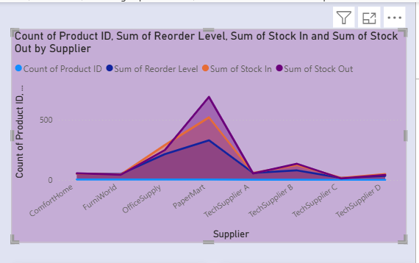
1.Go to Report View.
2.Click Area Chart icon from Visualizations pane.
3.Drag Supplier→ X-Axis.
4.Drag Count of product ID,Sum of reorder level and sum of stock IN and OUT → Values.
5.Click drop-down on StockQuantity (Values field) → choose Sum.
6.(Optional) Drag Category → Legend to see category-wise trend.
Findings: Helps analyze stock trend over time. Identifies increase or decrease in stock levels. Useful for tracking inventory movement pattern.

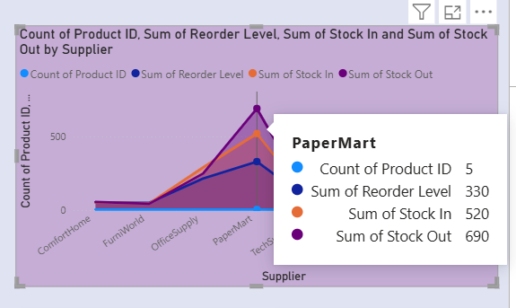
7.Pie chart:
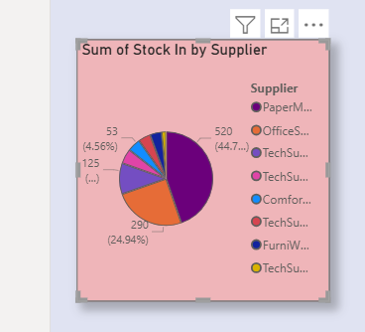
1. Go to Report View.
2.Click Pie Chart icon from Visualizations pane.
3.Drag Supplier→ Legend.
4.Drag Stock In → Values.
5.Click drop-down on ProductName (Values field) → choose Count.
Findings: Helps identify percentage of low stock products. Easy to understand stock condition at a glance. Useful for quick inventory health analysis.
8.Slicer:

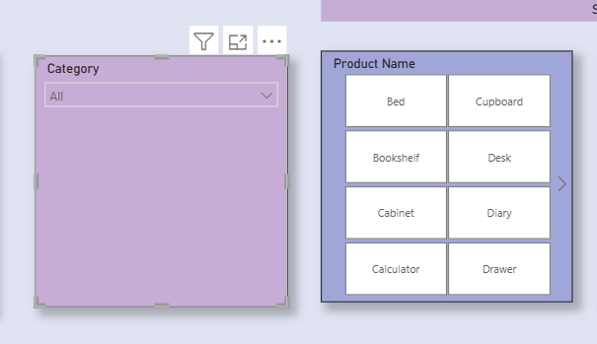
1.Go to Report View.
2.Click Slicer icon from Visualizations pane.
3.Drag Category → Field.
4.Resize the slicer properly on the report page.
5.(Optional) Click drop-down on slicer → Change to Dropdown style.
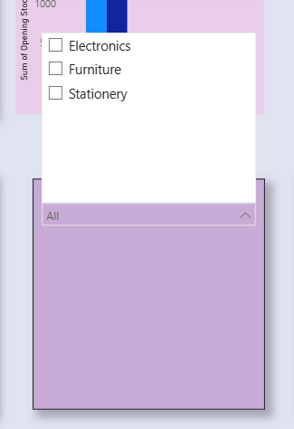
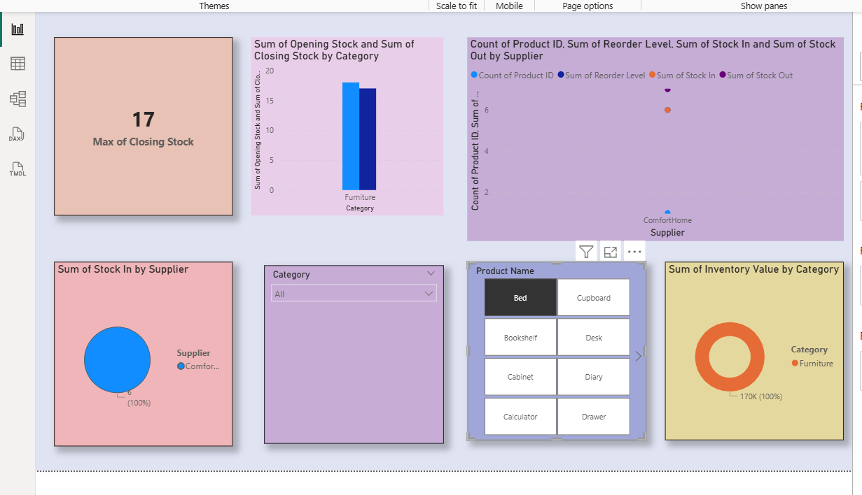
Here we can see how the all other charts, graphs and visualizations are changing when we click on product name(bed).
Findings: Helps analyze stock for a specific category. Makes dashboard interactive. Easy comparison between categories.
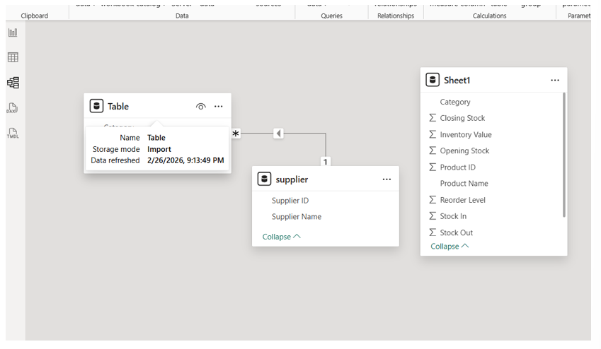
FINDINGS:Electronics has highest product count. Each supplier supplies different category products. One-to-Many relationship ensures correct filtering. Slicers improve interactivity.
9.Pie chart:
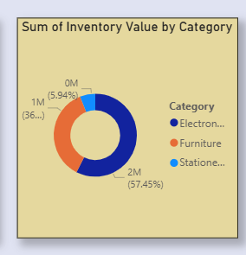
1.Go to Report View.
2.Click Donut Chart icon from Visualizations pane.
3.Drag Category → Legend.
4.Sum of inventory value → Values.
5.Make sure Values field is set to Sum.
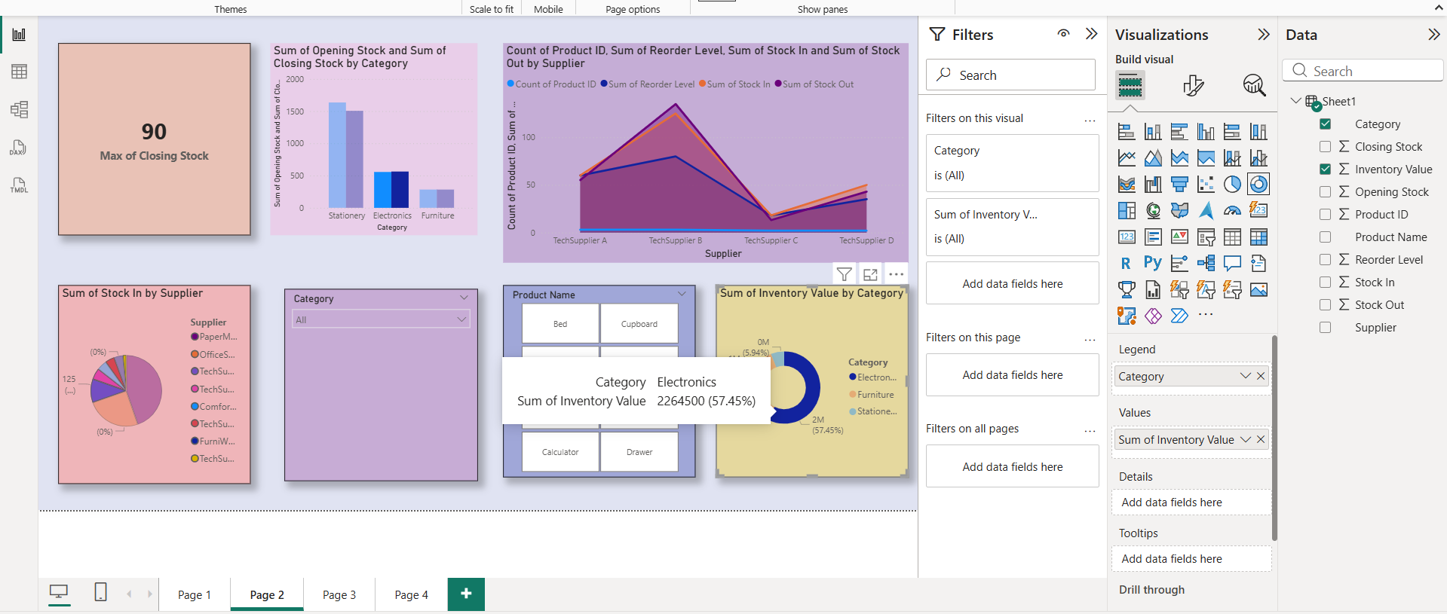
Findings: Helps identify which category generates more profit. Easy to compare category contribution. Useful for profit analysis and decision making.
10.Gauge:
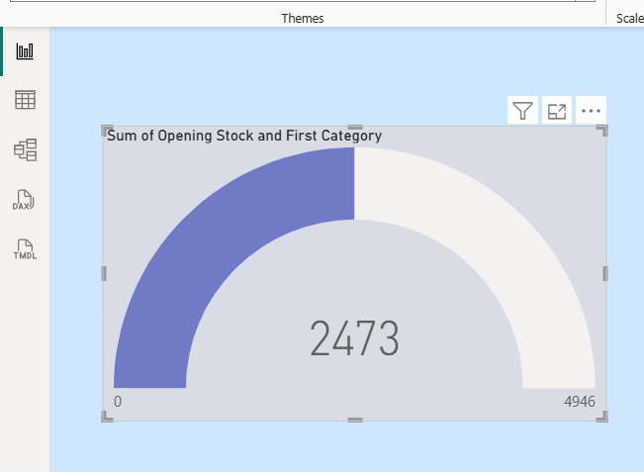
1.Go to Report View.
2.Click Gauge Chart icon from Visualizations pane.
3.Drag First category → Value.
4.Drag Sum of opening stock → Maximum Value.
5.(Optional) Drag a Target measure into Target Value field if created.
Findings: Helps monitor stock level against target. Easy to see if stock is under or over target. Useful for inventory performance tracking.
11.Line chart:
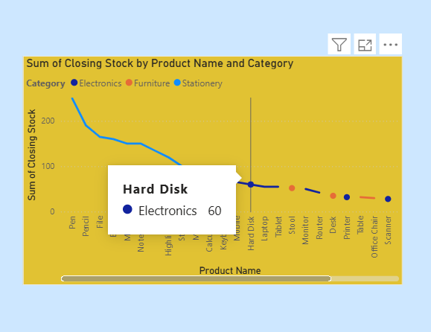
1. Go to Report View.
2.Click Line Chart icon from Visualizations pane.
3.Drag Product Name → X-Axis.
4.Drag Sum of Closing stock → Values.
5.Click drop-down on Category (Values field) → choose Sum.
6.(Optional) Drag Category → Legend to see category-wise trend.
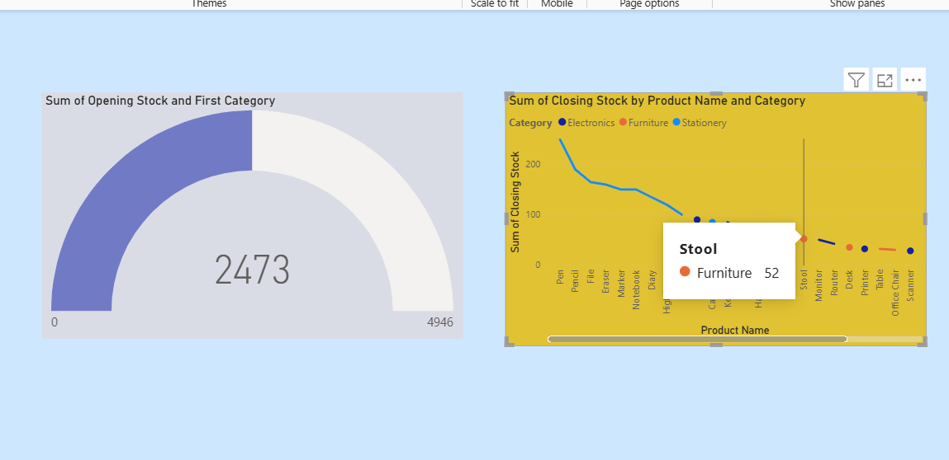
Findings: Helps identify stock trends over time. Shows seasonal or monthly stock changes. Useful for planning future inventory levels.
CONCLUSION:
The Inventory Management Dashboard successfully demonstrates data modeling and visualization using Power BI. The relationship between Inventory and Suppliers was established using One-to-Many cardinality. The dashboard provides clear insights into product categories and supplier contributions.
Overall, this project shows effective usage of Power BI for inventory data analysis.

